\*\*\*Amazon DynamoDB\*\*\*

Question: Set Up DynamoDB Auto Scaling and Alerts

Task: Configure Amazon DynamoDB to handle variable workloads and ensure efficient utilization of resources.

Enable Auto Scaling for a DynamoDB table to adjust read and write capacity automatically.

Create a CloudWatch alarm that activates when the consumed write capacity units exceed 80% of the provisioned capacity for two consecutive 5-minute periods.

Define a scaling policy to trigger when the alarm is in the ALARM state and adjust the provisioned capacity as needed.

🡺

Step 1:-

First of all login to aws account and then go to dynamoDb service and then click on create table to create a dynamodb table.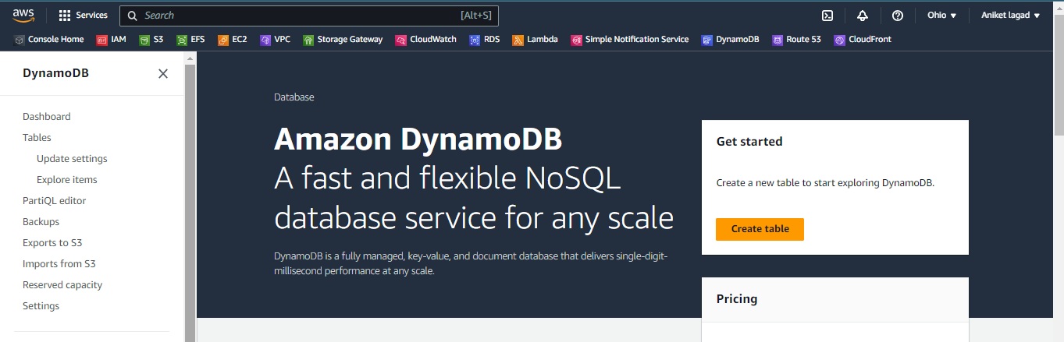

Step 2:-

Now you will see the setting of creating dynamodb table. So gave it table name and then gave it partition key name as in your data. And then select what is the format of table.

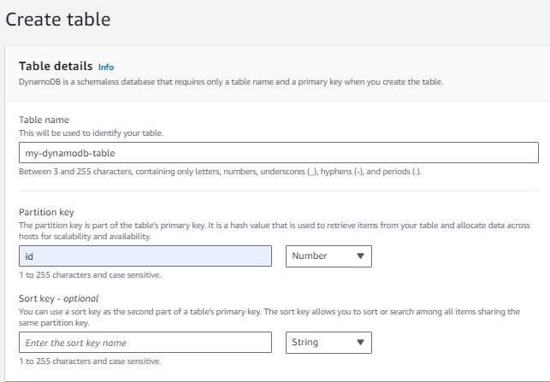

Step 3:-

Now table select as default it has less charges. And you have see the default table setting so see that what is include in it.

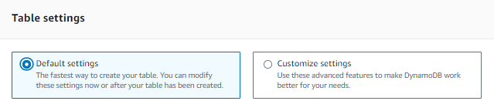

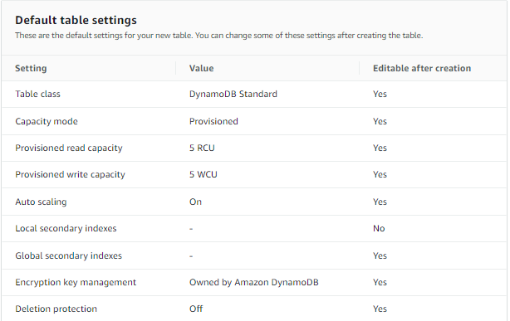

Step 4:-

And then click on create table and your table was ready.

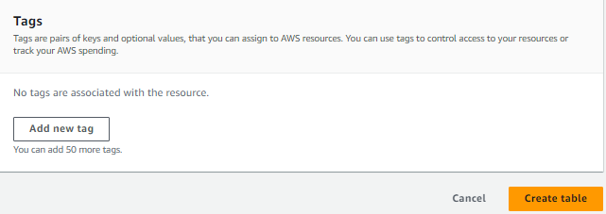

Step 5:-

Now you have to enable auto scaling to dynamodb table so click on tables session and click on table in which you have to on auto scaling .

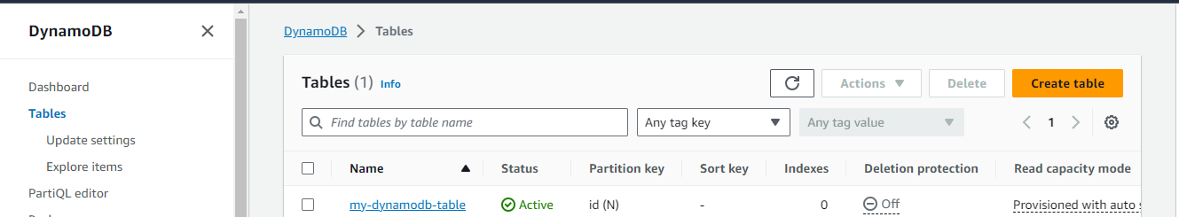

Step 6:-

After that click on actions option and then click on edit capacity.

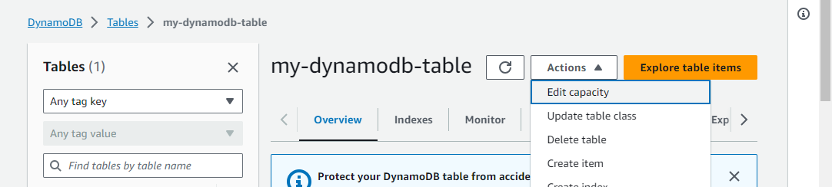

Step 7:-

Then you will see the read and write capacity setting. So firstly select capacity mode provisioned.

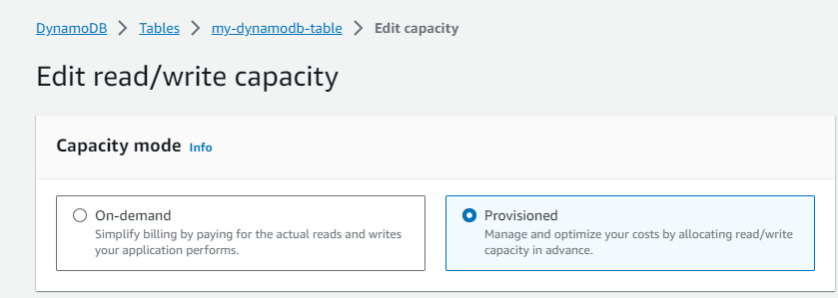

Step 8:-

Next you have see the capacity calculator in that nothing to change so scroll down and you will see the table capacity option so first on the read capacity and leave default setting of it. And next you will on the write capacity in that you have only change target utilization 70 to 80 and then scroll down. And then click on save changes.

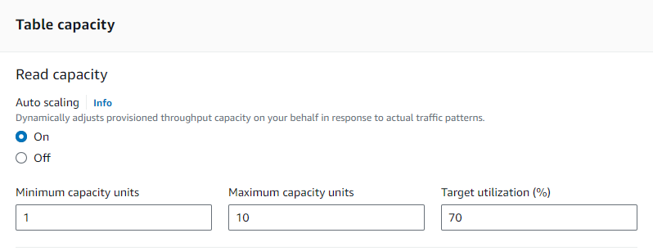

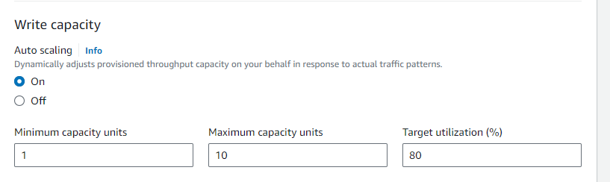

Step 9:-

After that go to CLOUDWATCH service where you have to create alarm. And then click on create alarm.

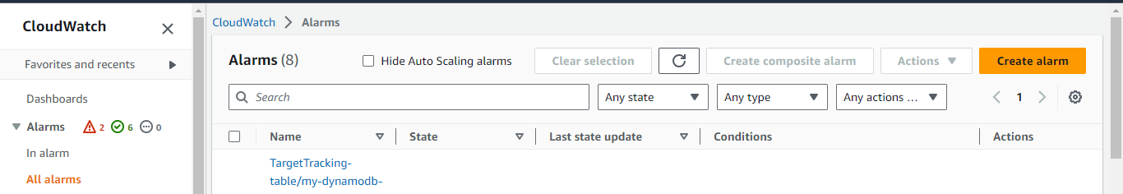

Step 10:-

Now you will see the specify metrics and condition so click on select metrics.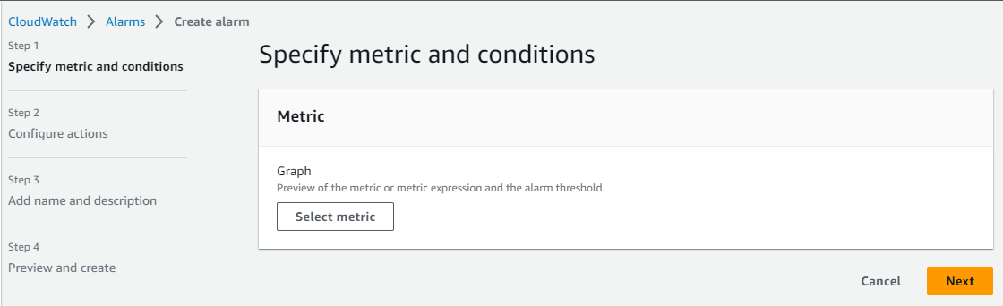

Step 10:-

Now click on browse option and then you will see aws default namespaces. In that namespaces click on dynamodb.

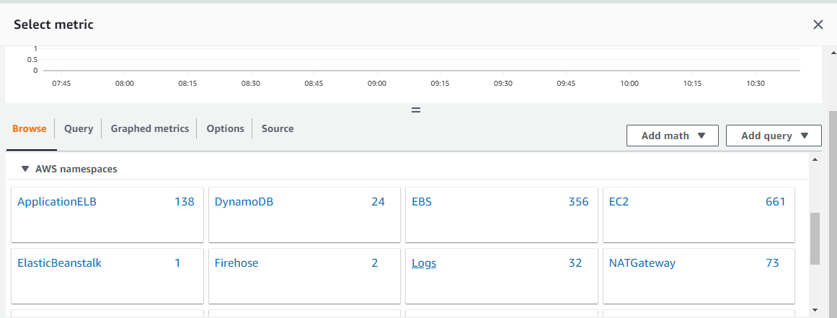

Step 11:-

Then click on table metrics.

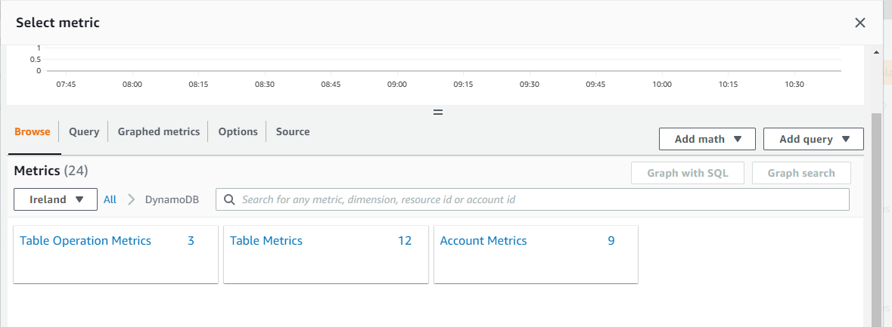

Step 12:-

Now select the consumed write capacity units option and then at the end click on select metric.

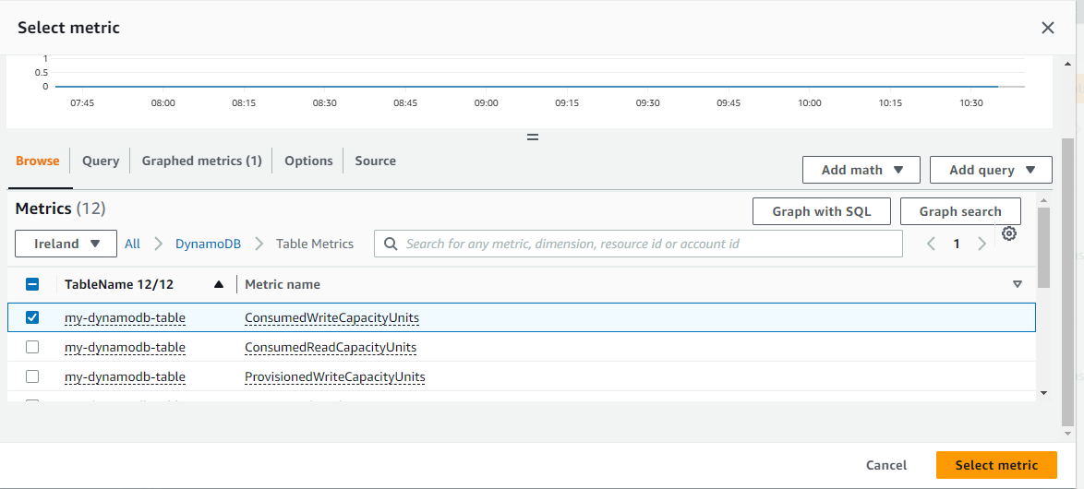

Step 13:-

Now select metric period is 5 minutes so and gave metric name and then scroll down.

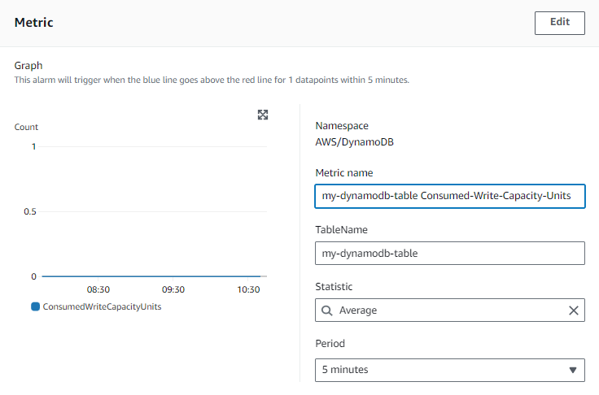

Step 14:-

Now select the conditions. First select threshold type static and then define then alarm condition greater than threshold value and in than value write 80 value.

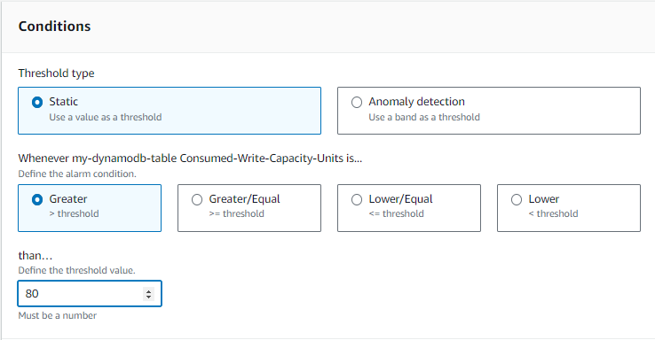

Step 15:-

And after that select datapoints to alarm 2 consecutive periods and then click on next.

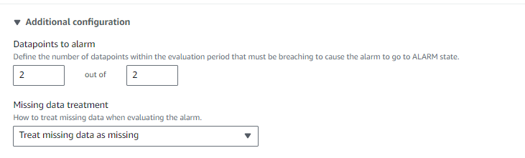

Step 16:-

Now configure actions when the alarm is trigger so we want to choose in alarm and then send notification the alarm is trigger so gave the sns topic and your email subscription attach it so whenever action perform you will be notified. And then click at the end option next.

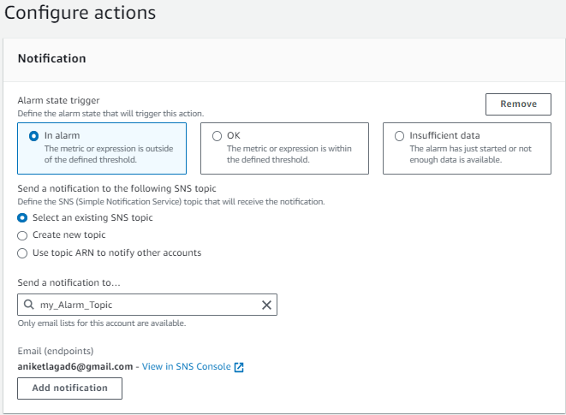

Step 17:-

Now have to gave this alarm name and dthen click on next. If you want describe this alarm you can or not then leave as it is .

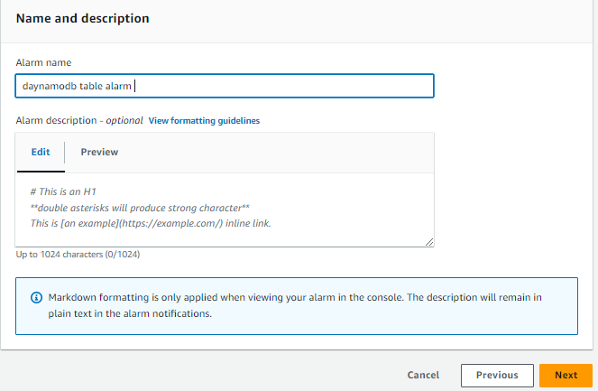

Step 18:-

Now see the all configuration and then scroll down at the end click on create alarm. And your alarm is set.

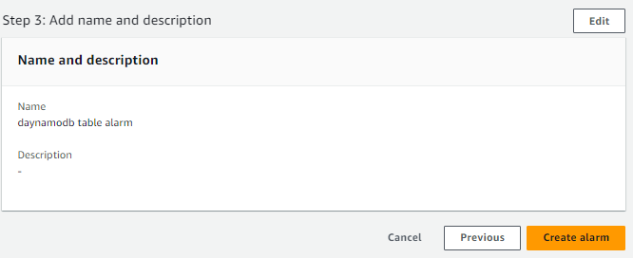

\*\*\*THE END\*\*\*